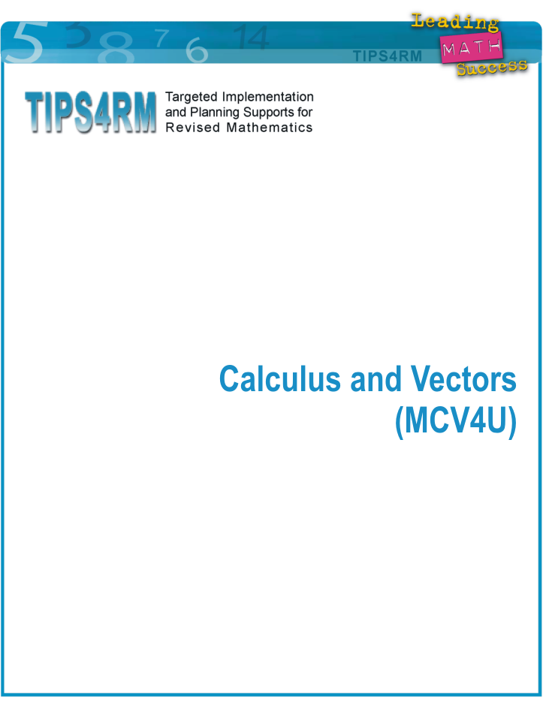

Calculus and Vectors: Content and Reporting Targets

Mathematical Processes across all strands: Problem Solving, Reasoning and Proving, Reflecting, Selecting Tools and Computational Strategies, Connecting, Representing, and Communicating

Unit 1 | Unit 2 | Unit 3
Explore rate of “flow” problems using non-algebraic means  - Explore contexts and solve problems where one needs to know rate of change at a specific point, using verbal and graphical representations of the function. Include examples where mechanical tools are not readily available, e.g., income flow, garbage accumulation rate.  - Analyse rates of change and provide qualitative solutions to problems, e.g., increase, decrease, tend towards something.  Standardize the process of finding instantaneous rate of change at a particular point  - Apply a standard process for determining instantaneous rate of change of a function at a specific point on its graph.  - For polynomial, simple rational, and radical functions, form, evaluate, and interpret the first principles definition of the derivative, using a fixed (numerical) value of “a,” e.g., What is the graphical significance of ? | Derivative Functions from First Principles  - Recognize numerical and graphical representations of increasing and decreasing rates of change.  - Use patterning and reasoning to determine that there is a function that describes the derivative at all points.  - For polynomial, rational and radical functions, determine, using limits, the algebraic representation of the derivative at any point.  Application of Derivatives of Polynomial Functions  - Graph, without technology, the derivative of polynomials with given equations.  - Given the graph of the derivative, sketch the original polynomial.  Derivative Functions Through Investigation  - Through investigation, determine the algebraic representation of the derivative at any point for exponential, logarithmic and sine/cosine functions.  Applications of Derivatives, Given Algebraic Representations  - Pose and solve problems that require identifying conditions that result in a desired rate of change. | Derivative Functions: Properties and their Applications  - Investigate properties of derivatives (power rule, chain rule as change of scale and as patterning, no quotient rule use product rule, Sample Problem: Examine the relationship between the derivative of a function and the derivative of its inverse. Generalize the power rule for all rational powers).  - Apply these properties to form derivatives of functions and simple combinations of functions (no simplification of derivatives formed outside of problem-solving contexts).
Unit 4 | Unit 5 | Unit 6
Applications of Derivatives in Rate of Change and Optimization Problems, Including Those Requiring Modelling  - Solve rate of change and optimization problems given algebraic models.  - Solve rate of change and optimization problems requiring the creation of an algebraic model (more variety in problems to get at various types of algebraic simplification and analysis).  - Solve problems calling for the modelling of the rate of change flow problems), not necessarily finding the original function but just a property of it, e.g., point of inflection. | Representing Vectors  - Introduce vectors in 2-D and 3-D.  - Represent vectors geometrically and algebraically.  - Operate with vectors.  - Solve problems involving vectors. | Representing Lines and Planes  - Parametric equations of functions.  - Represent lines and planes in a variety of ways.  - Find intersections of two planes.  - Find intersections of three planes.

Rationale
Teaching Calculus before Vectors
- Provides a natural flow from Advanced Functions to this course and students build on prior knowledge
- Calculus problems are situated in a two-dimensional context while vector problems progress from two-dimensions to three-dimensions.
- The introduction of parametric equations can help make connections.

Focusing Unit 1 on rates of change problems:
- Provides an opportunity for students to investigate a variety of real-world contexts involving change; develops an appreciation of the need to analyse rates of change
- Establishes a need for algebraic representations of rates of changes, e.g., the need for precision, for information at many different data points

Separating Units 1, 2, and 3:
- Introduces abstract concepts at a developmentally appropriate pace
- Provides opportunities to connect each abstract concept to problem solving situations
- Provides the time for students to investigate and consolidate conceptual understanding of rates of change, derivatives and limits, prior to combining these concepts with algebraic procedures

Graph analysis within Unit 2
- Curriculum revisions focus curve sketching on polynomials only.
- Graph analysis can be one of the strategies students use to confirm the reasonableness of solutions to problems in Unit 4.

Problems requiring modelling congregated in Unit 4
- These problems require students to choose from amongst all possible function types when formulating a mathematical model.
- The problem solving in Unit 4 provides a segue from calculus to vectors.

Numbers of Units
- It is recommended that calculus concepts be taught in of the time available, and that vectors be taught in of the time available.

Calculus and Vectors
Year Outline – Planning Tool

P Number of pre-planned lessons (including instruction, diagnostic and formative assessments, summative assessments other than summative performance tasks)
J Number of jazz days of time (instructional or assessment)
T Total number of days
SP Summative performance task

Unit | Cluster of Curriculum Expectations | Overall Expectations | P | J | T | SP
1 | - Explore rates of change in context to consolidate understanding from Advanced Functions  - Connect instantaneous rates of change with the derivative  - Connect the characteristics of the instantaneous rate of change with the characteristics of the function | A1 demonstrate an understanding of rate of change by making connections between average rate of change over an interval and instantaneous rate of change at a point, using the slopes of secants and tangents and the concept of the limit;  A2 graph the derivatives of polynomial, sinusoidal, and exponential functions, and make connections between the numeric, graphical, and algebraic representations of a function and its derivative. | 8 | 1 | 9
2 | - Investigate connections graphical and numerically between the graph of a function and its derivative  - Determine, using limits, the algebraic representation of derivatives  - Determine and apply the power, chain and product rules  - Apply power, product and chain rules to rational and radical functions  - Develop the derivatives of and  - Explore the relationship between and  - Solve problems involving instantaneous rates of change | A2 graph the derivatives of polynomial, sinusoidal, and exponential functions, and make connections between the numeric, graphical, and algebraic representations of a function and its derivative;  A3 verify graphically and algebraically the rules for determining derivatives; apply these rules to determine the derivatives of polynomial, sinusoidal, exponential, rational, and radical functions; and simple combinations of functions; and solve related problems. | 18 | 2 | 20
3 | - Examine the relationship between first and second derivatives and the original polynomial or rational function  - Sketch curves of polynomial or rational functions given information or equations  - Apply the properties of derivatives to real-world problems | B1 make connections, graphically and algebraically, between the key features of a function and its first and second derivatives, and use the connections in curve sketching;  B2 solve problems, including optimization problems that require the use of the concepts and procedures associated with the derivative, including problems arising from real-world applications and involving the development of mathematical models. | 8 | 1 | 9
4 | - Solve rate of change and optimization problems in a wide variety of contexts using properties of derivatives  - Collect data, create mathematical models and solve problems arising from real-world contexts | B2 solve problems, including optimization problems that require the use of the concepts and procedures associated with the derivative, including problems arising from real-world applications and involving the development of mathematical models. | 11 | 2 | 13
5 | - Introduce vectors in two-space and three-space  - Represent vectors geometrically and algebraically  - Determine vector operations and properties  - Solve problems involving vectors | C1 demonstrate an understanding of vectors in two-space and three-space by representing them algebraically and geometrically and by recognizing their applications;  C2 perform operations on vectors in two-space and three-space, and use the properties of these operations to solve problems, including those arising from real-world applications. | 16 | 3 | 19
6 | - Represent equations of lines in two-space and three-space using a variety of forms  - Investigate intersections of planes  - Solve problems involving planes arising from real-world contexts | C3 distinguish between the geometric representations of a single linear equation or a system of two linear equations in two-space and three-space, and determine different geometric configurations of lines and planes in three-space;  C4 represent lines and planes using scalar, vector, and parametric equations, and solve problems involving distances and intersections.
 | Summative Performance Tasks |  |  |  |  | 12
 | Total Days |  | 64 | 9 | 73 | 85

The number of prepared lessons represents the lessons that could be planned ahead based on the range of student readiness, interests, and learning profiles that can be expected in a class. The extra time available for “instructional jazz” can be taken a few minutes at a time within a pre-planned lesson or taken a whole class at a time, as informed by teachers’ observations of student needs.

The reference numbers are intended to indicate which lessons are planned to precede and follow each other. Actual day numbers for particular lessons and separations between terms will need to be adjusted by teachers.

Appendix A: Electronic Learning Objects to Support MCV4U

E-Learning Ontario Web Site: MGA4U Unit 3 Vectors
http://www.elearningontario.ca/eng/Default.aspx

Activity 2: Vector Laws
The last applet on Vector Laws allows the user to investigate the commutative, associative, distributive properties of two-space vectors in geometric form.

At the bottom of Activity 2 is a link to the University of Guelph’s Physics department where a tutorial for vectors is provided.

Activity 3: Applications of Geometric Vectors
The second applet in the Velocity Java Applets allows the user to investigate the resultant vector for a boat crossing a river. The user controls two-space vectors in geometric form for the boat’s velocity and the current.

Activity 5: Algebraic Vectors
The first applet allows users to interactively explore the connections between geometric and algebraic forms of vectors in two-space.

At the end of this activity is a link to a three-space Graphing Tool that allows students to graph points, lines, and planes in various forms.

Activity 6: Operations with Algebraic Vectors
There are four applets on addition of vectors, scalar multiplication, unit vectors, and position vectors. They allow the user to interactively manipulate two-space vectors.

E-Learning Ontario Web Site: MGA4U Unit 5 Vector Methods with Planes and Lines

Activity 1: Equations of Lines in two-space
There are five guided and three interactive applets on forms of vector equations, how to convert between forms, distance from a point to a line.

Activity 3: Intersection of Lines
There are two guided applets on intersection of lines in two-space and three-space.

Activity 5: Equations of Planes
There are four guided applets on the forms of equations of planes and how to convert between forms.

Activity 6: Intersection of a Line and a Plane
There is one guided applet.
Appendix A: Electronic Learning Objects (continued)
to Support MCV4U

Activity 7: Intersection of Planes
There is one guided applet on solving systems of planes algebraically.

Activity 8: Task: X, Y, and Z Factor
An open ended task using the three-space Graphing Tool allows students to consolidate vector concepts.

Vector Applets on the Web

NCTM
http://standards.nctm.org/document/eexamples/chap7/7.1/index.htm
This site has two applets. The first illustrates the components of a vector to control a car. The user interactively controls the speed and direction. The second illustrates vector addition for an aircraft flying that is acted upon by wind. The user controls the speed and direction of both the aircraft and wind.

Syracuse University
http://physics.syr.edu/courses/java-suite/crosspro.html
This applet demonstrates cross product of two vectors in three-space. It allows users to interactively change the vectors and see the resulting cross-product. The two vectors are limited to one plane but the plane can be moved to different viewing angles.

International Education Software
http://www.ies.co.jp/math/products/vector/menu.html
This Japanese site has a collection of applets that cover a wide variety of two-space and three-space vector topics. The controls are not very user-friendly but there are topics covered here like vector forms of lines in two-space and three-space that are not covered on other sites.

Professor Bob’s Physics Lab (Rob Scott)
http://www.after4.ca/SchoolStuff/PhysicsLab/roomnojpgtest.html
This interactive site has flash applets on various Physics topics. Some topics such as Milliken and Momentum labs allow students to apply vector concepts.

B.Surendranath Reddy (Physics Teacher in India)
http://surendranath.org/Applets.html
This site has several applets that can be used in MCV4U. For vectors there are applets for addition, cross product of vectors, converting between Cartesian and directed line segment forms and several kinematics applets. For calculus there are applets for instantaneous speed and velocity.

